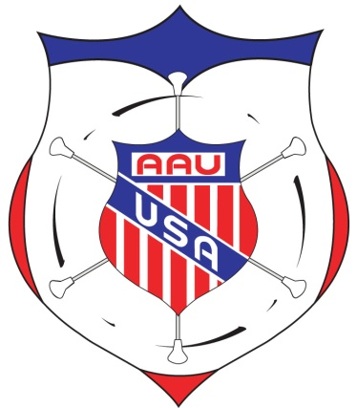**January 2012**

**Dear AAU Baton Twirling District Championship Director:**

**We thank you for your willingness to conduct an AAU District Championship!**

**DIRECTOR’S RESPONSIBILITIES AND CHECKLIST:**

1. **MEMBERSHIP –** All Director’s, participating Coaches, and Athletes **MUST** be current AAU members. Membership must be obtained online at [www.aausports.org](http://www.aausports.org), click on the Join Now button located on the right hand side.
2. **RULES –** All AAU District Championships **MUST** be administered according to the AAU Baton Twirling Rules contained in the 2011-12 AAU Baton Twirling Handbook. This is available on the AAU Baton Twirling website at [www.aaubaton.org](http://www.aaubaton.org), click on the tab Rules/Info.
3. **JUDGES –** Judges **MUST** be certified through their individual Districts.
4. **SANCTIONING –** First, please complete and mail the “Qualifying Events” form located in the Directors Packet to the address indicated for approval. After approval please submit your event sanction online. As a Contest Director, please be familiar with AAU sanctioning guidelines.
5. **FINANCES –** Develop a **BUDGET** for your competition.

* All expenses are your responsibility. (i.e. facility, awards, etc…)

1. **AWARDS –** Order awards for District Championships from the AAU National Headquarters after you have obtained your approved sanction.

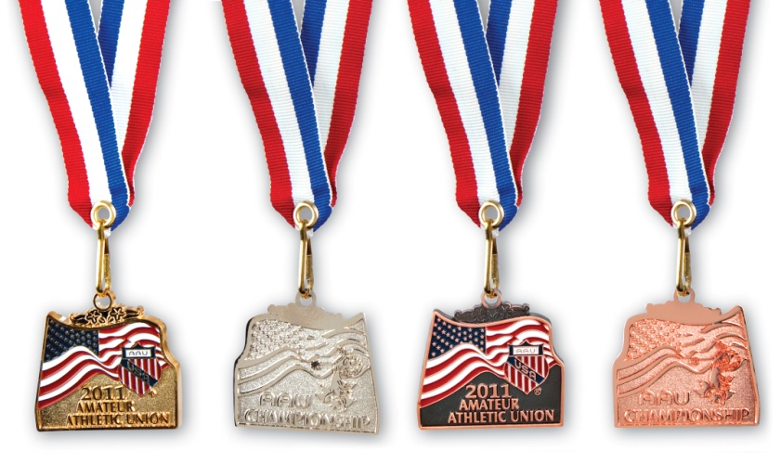To download an order form at please visit the AAU web site at [www.aausports.org](http://www.aausports.org) –under “Medals & Banners”. Allow at least 4-6 weeks for delivery.

Medals are given to the top three places in each division. Additional medals may be purchased for more placements. Team & Corp trophies may be used instead of individual medals.

1. **SCORE-SHEETS –** Use scoresheets posted on the AAU Baton Twirling Directors page at [www.aaubaton.org](http://www.aaubaton.org).
2. **REGISTRATION INFORMATION** **–** Mail your entries to all teams and/or clubs in your area.

You can go through the AAU National Office to spread the news of your Qualifier to members in your District. Contact Jennifer Miles either by calling (407) 934-7200 or emailing [jennifer@aausports.org](mailto:amanda@aausports.org).

1. **ELIGIBILITY –** Remind all coaches and twirlers that participants must be current members of the AAU before they may participate in an AAU District Championship.
2. **PLAN AHEAD –** with your group to cover the logistics of the competition, concession stand, first-aid station, evacuation procedures, etc.
3. **RESULTS & CONTEST WRAP–UP –** Within **1 week** of the completion of your competition, please send the following items to the AAU National Headquarters, c/o Jennifer Miles, P O Box 22409, Lake Buena Vista, FL, 32830, so that eligibility may be checked for upcoming events:

* Finalized results for each Event/Level/Age plus Group results – use form provided. Form should be filled out at tabulation.
* List of all participating athletes, groups and coaches with addresses, telephone, email, phone numbers and AAU membership numbers – use form provided.

1. **PHYSICAL PLANNING –** for the District Championship – Set-up the competition area so that there is a separate warm-up area and holding area for the events. Other twirlers, family members and coaches should not be allowed on or near the competition floor or the judges. Floor tape should clearly mark the twirling area and the judges. Be sure you have enough stop watches, pencils, score-sheets, calculators, etc. for your needs.
2. **PACKETS FOR QUALIFIERS FOR THE AAU JUNIOR OLYMPIC GAMES –** The only ways that qualified athletes can register for the AAU Junior Olympic Games is online at [www.aaujrogames.org](http://www.aaujrogames.org) following the District Championships. Participants placing in the top 10 should register online by the deadline date indicated on the entry information for the AAU Junior Olympic Games.

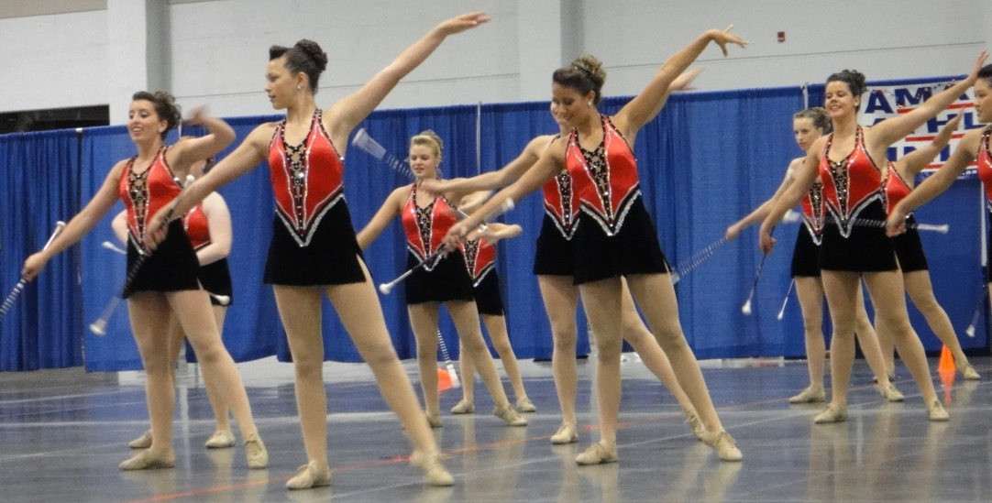

**Good Luck with your AAU Baton District Championship!**